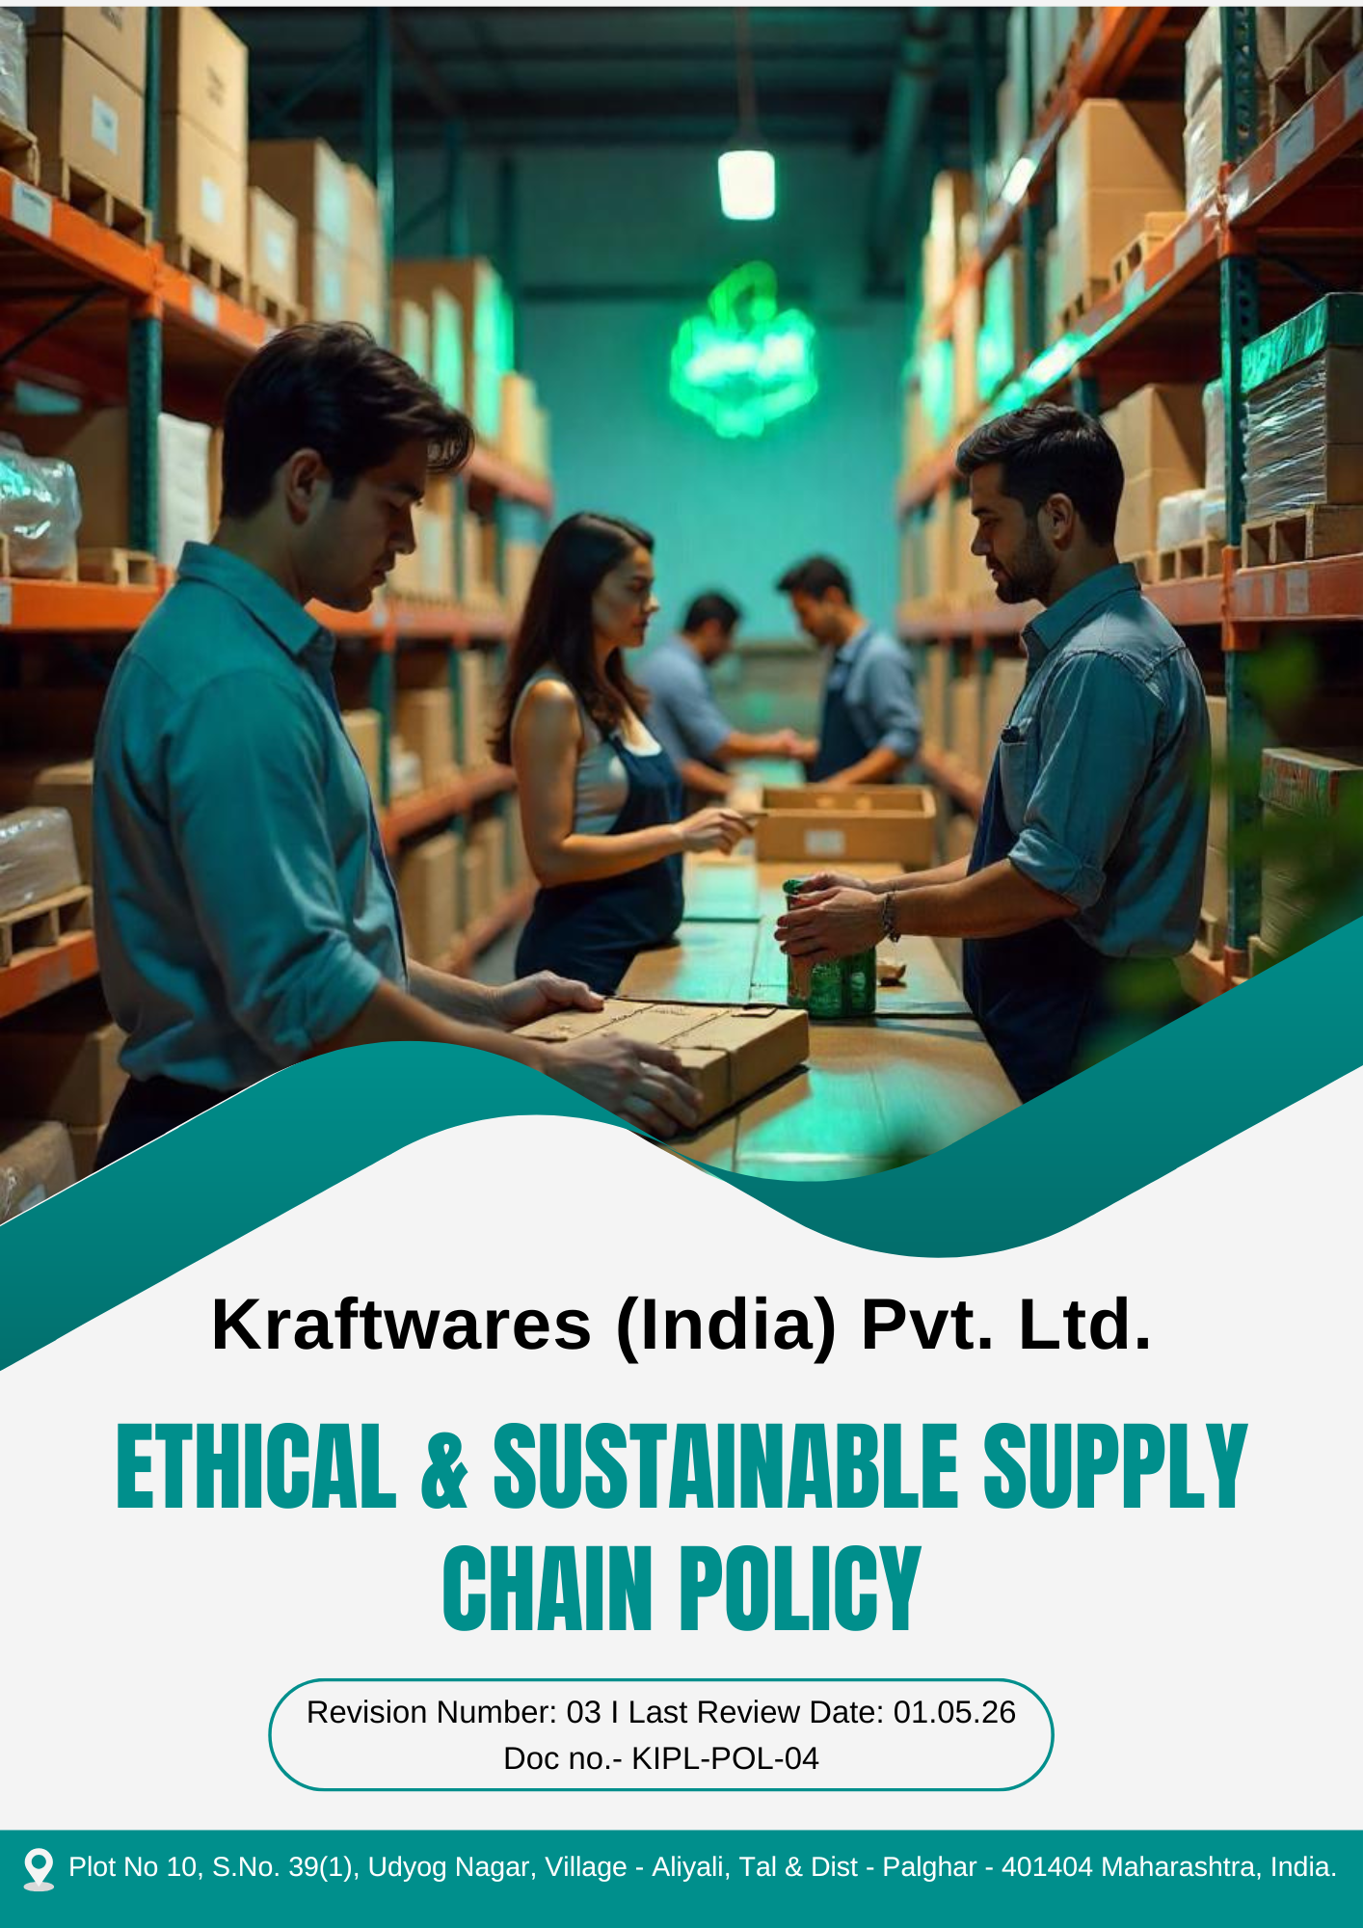

Table of Contents
PREFACE 3
SCOPE 3
POLICY DECLARATION 3
OBJECTIVES 4
ALIGNMENT WITH SUSTAINABLE DEVELOPMENT GOALS (SDGS) 5
RESPONSIBILITIES 5
MONITORING, REPORTING AND TRANSPARENCY 6
CONTINUOUS IMPROVEMENT 6
REVIEW MECHANISM 7
EMPLOYEE ACKNOWLEDGEMENT 8

PREFACE

Kraftwares (India) Pvt. Ltd. is committed to integrating ethical, responsible, and sustainable practices across its supply chain operations. The Company recognizes that procurement and supplier relationships play a critical role in promoting environmental stewardship, ethical business conduct, fair labor practices, and respect for human rights.
The Ethical and Sustainable Supply Chain Policy establishes the framework for managing supplier relationships and procurement activities in a responsible manner. Through this policy, Kraftwares (India) Pvt. Ltd. aims to ensure that all goods and services are sourced from partners who operate in compliance with applicable laws, uphold ethical standards, and support environmental and social sustainability throughout the supply chain.

SCOPE

This Policy is applicable to following sites and all of its employees, workers, sub-contractors and other stakeholders:

Sr. No. | Site | Address
1 | Kraftwares (India) Pvt. Ltd. | Plot No 10, S.No. 39(1), Udyog Nagar, Village - Aliyali, Tal & Dist - Palghar - 401404 Maharashtra, India.

POLICY DECLARATION

Kraftwares (India) Pvt. Ltd. is committed to conducting business with integrity by ensuring our procurement practices align with sustainability principles. We aim to minimize environmental impact, promote fair labor standards, and protect human rights. By partnering with suppliers who share these values, we will foster sustainable and ethical practices across our supply chain. We will continuously evaluate and improve our procurement processes to align with evolving sustainability trends, regulations, and best practices, with 2022 as the baseline year for tracking progress and performance.

OBJECTIVES

- Encourage suppliers to adopt environmentally responsible practices aimed at reducing energy consumption, emissions, water use, and waste generation.
- Support the integration of sustainable materials, resource efficiency, and pollution prevention practices within the supply chain.
- Promote responsible labour practices within the supply chain by encouraging suppliers to comply with applicable labour laws and internationally recognized human rights principles promoted by the International Labour Organization.
- Ensure suppliers maintain safe and healthy working conditions and prohibit child labour, forced labour, discrimination, and harassment across their operations.
- Strengthen supplier accountability by integrating social responsibility criteria into supplier evaluation and engagement processes.
- Support suppliers in improving their sustainability performance through knowledge sharing, training programs, and awareness initiatives.
- Promote collaboration with suppliers to enhance responsible sourcing practices and long-term sustainability across the supply chain.
- Promote an inclusive and diverse supplier base by providing fair and equal opportunities for suppliers of different sizes, backgrounds, and ownership structures.
- Ensure supplier selection processes are transparent, objective, and based on fair evaluation criteria.

TARGETS
The year 2022 has been established as the baseline year for measuring progress against all the below given targets outlined in this policy.
- Ensure that 50% of procurement is sourced from suppliers with recognized environmental certifications such as ISO 14001 Environmental Management System by year 2030 through preferential sourcing from certified suppliers.
- Implement a circular procurement model, aiming for 30% of procured materials to be recyclable or made from recycled content by year 2030.
- Source 10% of raw materials from local suppliers by year 2030 to reduce carbon emissions associated with transportation.
- Ensure 100% of key suppliers sign and comply with the Supplier Code of Conduct by year 2030.
- Achieve 100% supplier compliance with our labor and human rights standards by year 2030, verified through annual audits.
- Ensure that 50% of suppliers implement one worker welfare or social improvement initiative by year 2030.
- Establish a supplier diversity program, ensuring 20% of procurement spend is directed to diverse and minority-owned businesses by year 2030.
- Expand the supplier network by engaging 5 new diverse suppliers by year 2030.
- Conduct two supplier capacity-building or collaboration initiatives per year focused on ESG improvement areas by year 2030
- Provide guidance or training on environmental and social practices to 50% of suppliers by year 2030.
- Provide sustainability training to 100% of procurement team members annually to strengthen awareness and implementation of responsible sourcing, environmental, and social procurement practices.

ALIGNMENT WITH SUSTAINABLE DEVELOPMENT GOALS (SDGS)

The Company’s supplier sustainability initiatives are aligned with the Sustainable Development Goals established by the United Nations, particularly the following:
- SDG 8: Decent Work and Economic Growth – By ensuring ethical labour practices, supplier Code of Conduct compliance, worker welfare initiatives, and human rights adherence across the supply chain.
- SDG 12: Responsible Consumption and Production – Through circular procurement, use of recyclable materials, supplier environmental compliance, and promotion of sustainable sourcing practices.
- SDG 13: Climate Action – By promoting local sourcing, reducing transport-related emissions, and improving environmental performance of suppliers.
- SDG 17: Partnerships for the Goals – Through supplier capacity building, ESG training programs, and collaborative sustainability initiatives.

RESPONSIBILITIES
The Sustainability Manager will lead the creation of the annual Sustainable Sourcing Performance Report, collaborating with key stakeholders to ensure comprehensive assessment and reporting. The report will be prepared with input from:
- Sustainability Manager – Accountable for overseeing the implementation of the sustainable sourcing policy, conducting supplier evaluations, and ensuring alignment with the company’s sustainability goals.
- Procurement Team – Responsible for selecting suppliers who meet the company’s environmental and labor standards, facilitating supplier training, and ensuring ongoing compliance with sustainability criteria.
- HR and Compliance Team – Responsible for monitoring supplier adherence to labor and human rights standards, identifying non-compliance issues, and ensuring corrective actions are taken as needed.

MONITORING, REPORTING AND TRANSPARENCY
Kraftwares (India) Pvt. Ltd. monitors its ethical and sustainable supply chain performance across key areas, including responsible sourcing, supplier environmental and social compliance, occupational health and safety practices, and adherence to applicable regulatory requirements. Defined Key Performance Indicators (KPIs) are tracked through internal procurement and supplier management processes to evaluate progress against sustainability objectives.
Performance is reviewed on a quarterly basis and consolidated for senior management review to support responsible sourcing and informed decision-making. Annual assessments are conducted to identify achievements, gaps, and areas for improvement, and relevant outcomes are communicated to appropriate stakeholders to promote transparency and accountability. All monitoring and reporting activities are aligned with applicable laws, recognized sustainability frameworks, and industry best practices to ensure consistency, accuracy, and credibility.

CONTINUOUS IMPROVEMENT
Kraftwares (India) Pvt. Ltd. is committed to continuously improving its ethical and sustainable supply chain practices through regular review of performance, supplier feedback, and evolving ESG standards.
Improvement actions will be driven by KPI monitoring, audit findings, and corrective actions to strengthen procurement processes and supplier compliance. The Company will also enhance training and capacity-building initiatives to support responsible sourcing and ensure ongoing alignment with best practices and regulatory requirements.

REVIEW MECHANISM
The Sustainability Manager will conduct an annual review of this policy to evaluate its effectiveness in achieving sustainable sourcing goals. This will include assessing supplier performance, monitoring responsible sourcing practices, and addressing any non-compliance. The review will incorporate supplier audits, feedback from the procurement team, and the results of training programs. Based on these findings, updates will be made to ensure alignment with ESG standards and maintain the company’s commitment to sustainable procurement.

REV. No. 03

LAST REVIEW DATE: 01.05.2026 NEXT REVIEW DATE: 01.05.2027

APPROVED BY:

EMPLOYEE ACKNOWLEDGEMENT

I hereby acknowledge that I have read and understood the Ethical and Sustainable Supply chain Policy of Kraftwares (India) Pvt. Ltd.. I am aware of the Company’s commitment to ethical, transparent, and sustainable sourcing of all materials, products, and services.
I understand that sustainable procurement requires respecting human rights, ensuring fair labour practices across the supply chain, avoiding materials associated with conflict or unlawful activities, and complying with applicable environmental and social regulations. I recognize that maintaining responsible sourcing practices is a shared responsibility that supports the integrity, sustainability, and reputation of the Company.
By signing this document, I commit to following responsible procurement practices, promptly reporting any concerns through the appropriate reporting channels, and actively participating in relevant training and awareness programs. I affirm my responsibility to contribute to a supply chain built on ethics, transparency, accountability, and environmental and social responsibility.

Employee Name | : _________________________
Employee ID | : _________________________
Department | : _________________________
Signature | : _________________________

